Lasalliana – Volume 22 – October, 1991
* lasallitina
22 -16-D -58
TOWARDS
A BETTER UNDERSTANDING
OF THE LASALLIAN FAMILY
1. WHAT IS THE LASALLIAN FAMILY? The �allian Family is a spiritual entity born of the ^{co}�u^{m}�n ��e^{e}� persons and groups ''who wish to denve their inspiration from De La Salle in order to grow as men and women of faith, at the service of the local Church, and as people particularly committed to the field of education" (Circ. 422, p.13).
"When we speak of the Lasallian Family we refer to that body of persons who make up those movements and grº�^{p}.s all of which have been forming according to t^{h}� spmtual and pedagogical experience of St. John BaptISt de La Salle" (Message of the 41st General Chapter to the members of the Lasallian Family, p.29).
2. WHERE DOES THE LASALLIAN FAMILY EXIST?
The Lasallian Family normally exists within the framework of a District. Why in a District ?
1. Because it is a clear and well-defined geographical sector of the Institute which already has all the ele ments,. structures, means and organisation· to ensure the umty and communion that are indispensable if we are to speak in terms of a family.
"The �istrict, as t�� ordinary communion existing among its co�umbes and Brothers, is more than a structure of government" (Rule 124).
2 Because it has a head, the Brother Visitor, "the guarantor of the unity and vitality of the District" (Rule 132).
3. Because _{1;1}ormally a District has a District Plan. This Plan states m general terms what the District plans to ?o ^{fo}� a given period of time with regard to the relig ious li^{f}� of th^{e}. ^{B}�others and its ministry of Christian educabon, a mISSion entrusted to the Institute by the Church. This Plan is implemented by means of clearly structured programmes.
4. �� each District has structures of government, orgalllSation and evaluation such as District Chapters,
District Councils, specialised permanent commissions ad ^{h}�c commissions, etc. whose work is complemen: tary, mterdependent and unified by common criteria, approach to work and planning of activities.
5. Because in a District is to be found the concrete reality in which the apostolate of the Institute is pur sued through formal education (schools, colleges in titutions) or informal (youth groups, Old Boys, �ial work groups, voluntary work groups, summer acti vit^{i}.e^{s}: married women catechists, Signum Fidei ... ). This IS the context in which the District Plan is im plemented.
All these advantages make the District the ideal framework for the birth, growth and consolidation of the Lasallian Family.
3. THE DISTRICT: A GREAT COMMUNI1Y OF COMMUNITIES
The District, which is a place of communion and participation, is made up of small groups of persons which we call communities.
1. In the first place there are the communities of Brothers whose identity is clearly defined in the Rule.
2. _{!h}ere are groups of lay people, the majority of w^{h}�ch have spr^{u}_ng up recently or are still being
tramed, whose aim and ideal are to become faith communities. These alone can guarantee the authen tic fulfilment of the baptismal covenant and the missionary commitment which is the consequence of this covenan_{t}.
It is within a District that Brothers' communities and the various lay groups, whether they are part of edu cational communities or not, work in a complementary manner to achieve the same aim: to fulfil the District Plan. Seen as a plan for all the communities of Bro thers and lay people, it can equally be called The District Lasallian Family Plan.
Br. Hernando Seba L6pez
C -LASALUANA N. 22 - Article 16 -Code D:Laity and Inst. Lasallian Family. (58) - Fratelli delle Scuole Cristiane - Via Aurelia, 476 - 001
BROTHERS OF THE CHRISTIAN SCHOOLS Via Aurelia, 476 – 00165 ROMA, Italia
Scanned at the Lasallian Resource Center De La Salle Institute – Napa, CA – USA
YOUNG PEOPLE
OLD BOYS
EDUCATIONA
COMUNITY
LAY
TEACHERS
LAY
HEADMASTERS
Lasalliana – Volume 22 – October, 1991
PARENTS
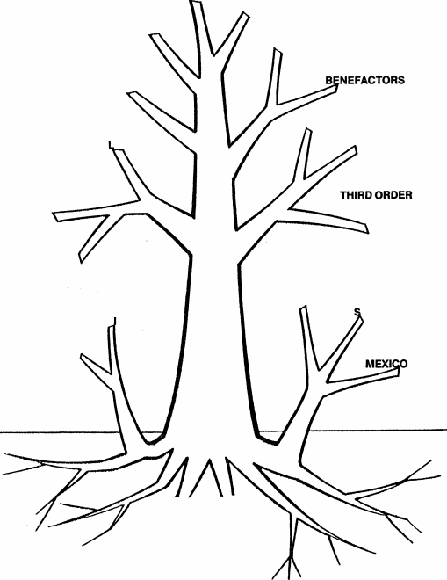
FRIENDS
AFILIATED MEMBERS
SIGNUM FIDEi
^{F.} s.
C.
I
N
UNION OF CATECHISTS OF CHRIST CRUCIF ED
s
T
I
T
u
T
E
DELASALLE
VIETNAMESE SI TERS
© -IASALLIA"-A N. 22 -Article 16 -Code D:Laity and Inst. Lasallian Family. (58) - Fratelli delle Scuole Cristiane -Via Aurelia, 476.-0016.5 Ronia
BROTHERS OF THE CHRISTIAN SCHOOLS Via Aurelia, 476 – 00165 ROMA, Italia
Scanned at the Lasallian Resource Center De La Salle Institute – Napa, CA – USA

