Universal Fraternity

Let us remember…, that we are in the Holy Presence of God. (pause)

Opening Prayer: Prayer for October 2025 – Pope Leo XIV

Lord Jesus,
You, who in diversity are one
and look lovingly at every person,
help us to recognize ourselves as brothers and sisters,
called to live, pray, work, and dream together.
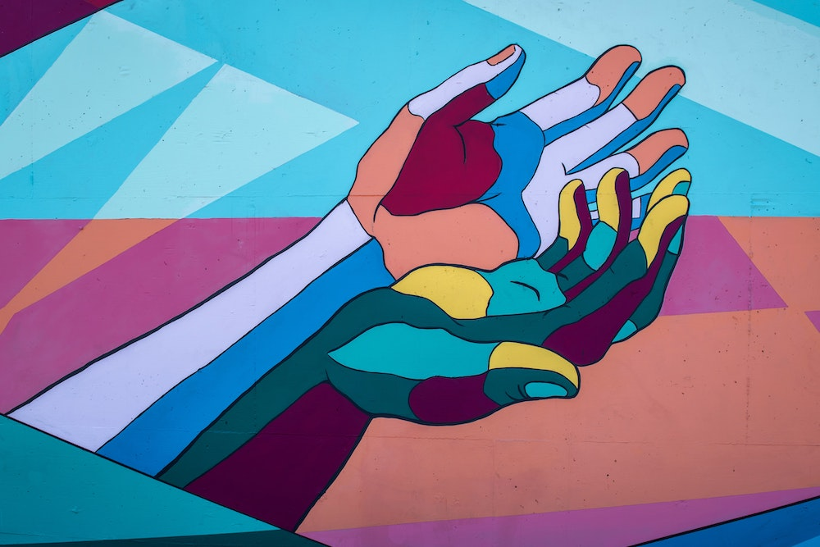

We live in a world full of beauty,
but also wounded by deep divisions.
Sometimes, religions, instead of uniting us,
become a cause of confrontation.
Give us your Spirit to purify our hearts,
so that we may recognize what unites us
and, from there, learn again how to listen
and collaborate without destroying.
May the concrete examples of peace,
justice and fraternity in religions
inspire us to believe that it is possible to live
and work together, beyond our differences.


May religions not be used as weapons or walls,
but rather lived as bridges and prophecy:
making the dream of the common good credible,
accompanying life, sustaining hope
and being the yeast of unity in a fragmented world.
Amen.

Bible Reading: Luke 10 (25-37)
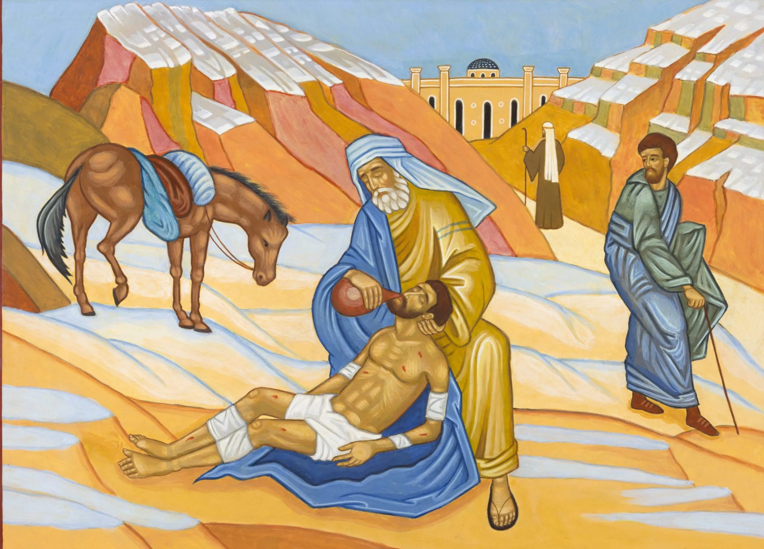
Reader 1: There was a scholar of the law who stood up to test him and said, “Teacher, what must I do to inherit eternal life?” Jesus said to him, “What is written in the law? How do you read it?” He said in reply, “You shall love the Lord, your God, with all your heart, with all your being, with all your strength, and with all your mind, and your neighbor as yourself.”

Reader 2: He replied to him, “You have answered correctly; do this and you will live.” But because he wished to justify himself, he said to Jesus, “And who is my neighbor?” Jesus replied, “A man fell victim to robbers as he went down from Jerusalem to Jericho.
Reader 1: They stripped and beat him and went off leaving him half-dead. A priest happened to be going down that road, but when he saw him, he passed by on the opposite side. Likewise, a Levite came to the place, and when he saw him, he passed by on the opposite side.

Reader 2: But a Samaritan traveler who came upon him was moved with compassion at the sight. He approached the victim, poured oil and wine over his wounds and bandaged them. Then he lifted him up on his own animal, took him to an inn and cared for him. The next day he took out two silver coins and gave them to the innkeeper with the instruction, ‘Take care of him. If you spend more than what I have given you, I shall repay you on my way back.’ Which of these three, in your opinion, was neighbor to the robbers’ victim?” He answered, “The one who treated him with mercy.” Jesus said to him, “Go and do likewise.”

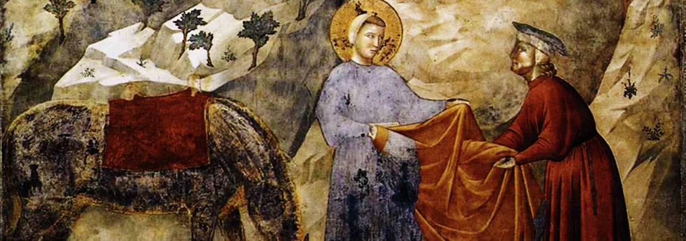

For quiet personal reflection: (1 minute of silence)
- Are there times when I “pass by on the opposite side” of situations I encounter?

- How I can bring more compassion, mercy and justice to these moments?


Reflection: Excerpts from - Becoming More by Having Less - (Lasallian Reflection 11: 2025-2026 pg.16-17)

Fratelli tutti reinforces that our ecological conversion must be grounded in universal fraternity. To be in right relationship with creation means recognizing our interdependence with all people and with nature. It invites us to embrace simplicity—not as deprivation, but as liberation. To be more by having less. To prioritize community over consumption, connection over isolation because to rediscover the community of creation is also to recognize that our patterns of living and consumerism impact the rest of creation.

Being more by having less begins at the heart because recognizing that all is connected is really to confront
ourselves with the questions: do I want to be connected with mother earth, with my sister, with my brother, and, yes, even with those whom we may find difficult to love or understand? It begs from us union of hearts and deep human connection.

This awareness and deep connection is then about being able to recognize whatever blinds and prevents us from integral relationships with humanity and all of creation. This is the Fratelli tutti invitation to universal fraternity whereby we allow ourselves, like the Good Samaritan, to be seen by the stranger on the road and are shaken to our human connection with the other by the suffering Christ. Solidarity in action!

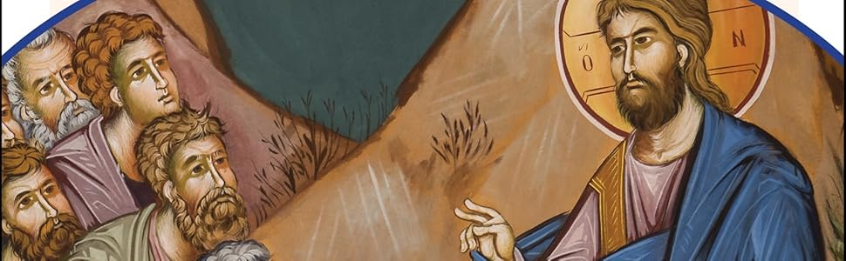

Reflection: Paths of Renewed Encounter (USCCB – Study Guide for Fratelli Tutti, chapter 7)

Reader 1: In [Fratelli Tutti], Pope Francis proposes an ethic of peace and nonviolence as a way to begin to create a community of global solidarity and a more universal fraternity. This invitation to renewed social friendship does not mean returning to the old way of doing things: “pain and conflict transform us” and the first step towards creating a more just society is working for a peace that allows us to both remember the past while also looking forward with hope and in pursuit of justice (no. 226).

Reader 2: As we seek to build a social unity that lifts up all our brothers and sisters, we must recognize that each person has something to contribute and that each of us is more than the worst thing we’ve ever done (no. 228). This requires working to overcome our divisions and recognizing that the task to build the common good necessitates an acknowledgment that we all belong to each other (no. 230).

Reader 1: The pursuit of peace and fraternity is an on-going task focused on the call to cultivate a “culture of encounter” (no. 232) and to work together to overcome inequality and lack of integral human development, which “make peace impossible” (no. 235).

Reader 2: A renewed commitment to encounter and social friendship requires a deeper understanding of forgiveness. Forgiveness does not mean failing to hold people accountable for injustice; rather, “true love for an oppressor means seeking ways to make him cease his oppression; it means stripping him of a power that he does not know how to use, and that diminishes his own humanity and that of others” (no. 241).

Reader 1: The challenge of justice requires the unceasing work to overcome anger and violence that deprives all of us of our dignity, and instead find the peace Christ calls us to cultivate among all our brothers and sisters. The task for peace is one that must be sought within a moment of conflict and must foster an opportunity for reconciliation within the community (no. 244). In doing so, we allow all who have been victims of injustice to place their needs at the center and determine the best path forward.

Reader 2: This is how we foster the opportunity for true reconciliation and forgiveness that honors the memories of past suffering and injustice: “We need to ‘keep alive the flame of collective conscience, bearing witness to succeeding generations to the horror of what happened,’ because that witness awakens and preserves the memory of the victims, so that the conscience of humanity may rise up in the face of every desire for dominance and destruction” (no. 249).

Reader 1: Pope Francis tells us that this ethic of peace and justice must hold the values of encounter, social friendship, and love at the center. We seek justice because it empowers those who have been harmed and promotes the common good, not out of anger or vengeance (no. 252). This understanding of justice calls into question all forms of conflict and violence. War is an example of a broken solution to conflict that has resulted in the “destruction in the fabric of national and global society” (no. 255).

For quiet personal reflection: (1 minute of silence)
- Where, in my life, do I cultivate a “culture of encounter”?

- How can I do a better job of seeking true justice, forgiveness, and peace?

Intentions:

Leader: At this time, we bring forward our prayers and petitions. For what or for whom shall we pray?

(You are invited to share a petition, and at the conclusion say: We pray to the Lord.)

Response: Lord, hear our prayer.

Closing Prayer: Hope Amidst Dark Clouds (USCCB – Study Guide Inspired by Fratelli Tutti, nos. 30, 54-55)

May your light break through dark clouds, O Lord! May your hope grow in our hearts even when the skies feel ominous. Fear, isolation, individualism, conflict: these are the winds that blow gusts of racism and inequality in our “throw-away world.” But we are saved together; not alone. So teach us, Lord, to hope. Show us the goodness you continue to sow. Show us the boldness of love to reject fear and embrace our neighbor. Make fertile the ground where seeds fall. Bring gentle rain and warm rays of sunlight. May we know your love shines bright. Through dark clouds, may your hope shine again. Amen.

St. John Baptist de La Salle…, pray for us!
Live Jesus in our hearts…, forever!

