A Shared Journey of Hope
Laudato Si, Fratelli Tutti, Lasallian Reflection 11

Let us remember…, that we are in the Holy Presence of God. (pause)

Opening Prayer: A Prayer to the Creator (Fratelli Tutti, Pope Francis Oct. 4, 2020)
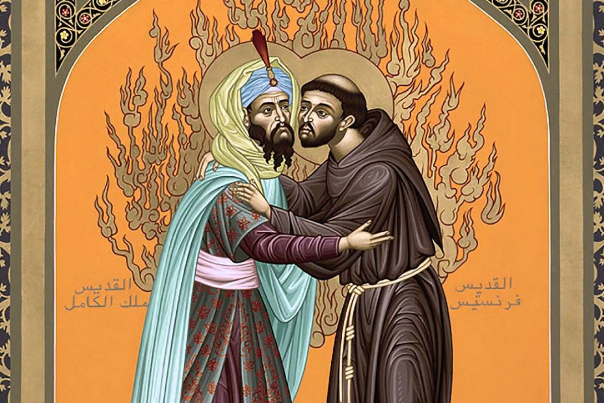
Lord, Father of our human family, you created all human beings equal in dignity: pour forth into our hearts a fraternal spirit and inspire in us a dream of renewed encounter, dialogue, justice and peace. Move us to create healthier societies and a more dignified world, a world without hunger, poverty, violence and war. May our hearts be open to all the peoples and nations of the earth. May we recognize the goodness and beauty that you have sown in each of us, and thus forge bonds of unity, common projects, and shared dreams. Amen.

Reading: 1 Corinthains 12 (12-27)
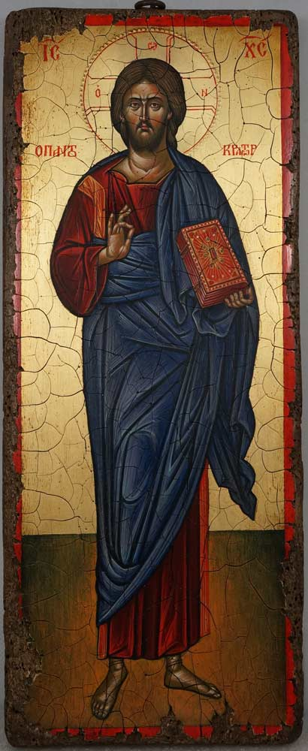
Reader 1: As a body is one though it has many parts, and all the parts of the body, though many, are one body, so also Christ. For in one Spirit we were all baptized into one body, whether Jews or Greeks, slaves or free persons, and we were all given to drink of one Spirit. Now the body is not a single part, but many. If a foot should say, “Because I am not a hand I do not belong to the body,” it does not for this reason belong any less to the body. Or if an ear should say, “Because I am not an eye I do not belong to the body,” it does not for this reason belong any less to the body. If the whole body were an eye, where would the hearing be? If the whole body were hearing, where would the sense of smell be?

Reader 2: But as it is, God placed the parts, each one of them, in the body as he intended. If they were all one part, where would the body be? But as it is, there are many parts, yet one body. The eye cannot say to the hand, “I do not need you,” nor again the head to the feet, “I do not need you.” Indeed, the parts of the body that seem to be weaker are all the more necessary, and those parts of the body that we consider less honorable we surround with greater honor, and our less presentable parts are treated with greater propriety, whereas our more presentable parts do not need this. But God has so constructed the body as to give greater honor to a part that is without it, so that there may be no division in the body, but that the parts may have the same concern for one another. If [one] part suffers, all the parts suffer with it; if one part is honored, all the parts share its joy.

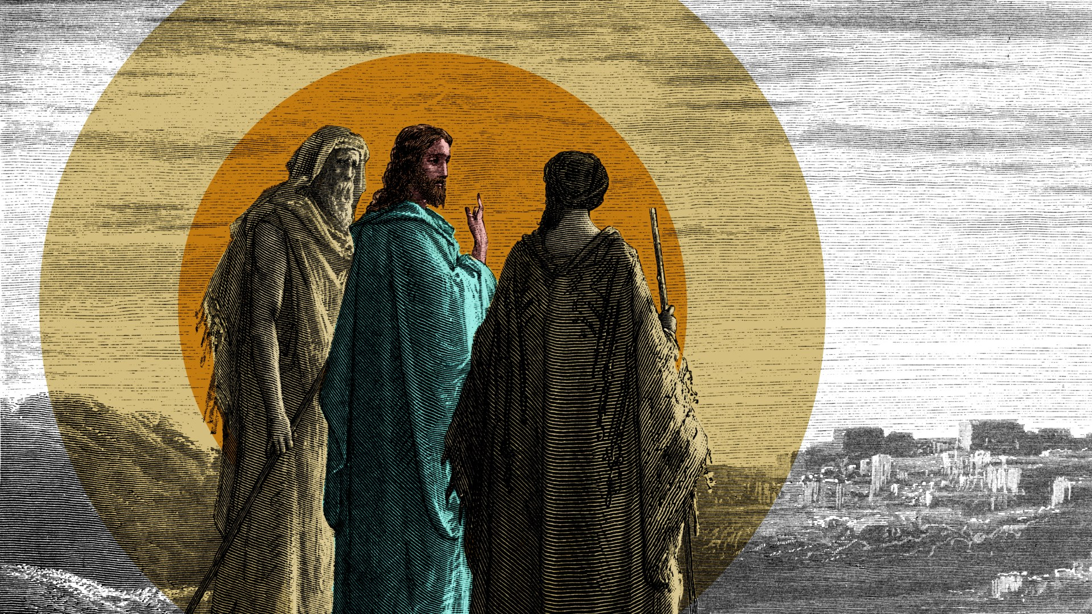
Reflection: A Shared Journey of Hope - (Lasallian Reflection 11: 2025-2026 pg.21-22)

Interconnectedness is not just part of the crisis, but also a source of solidarity and strength. This is the hope at the heart of both Laudato si’ and Fratelli tutti, that despite the enormity of the challenges before us, we are never alone. We are part of a community of creation, bound by love, responsibility, and the dream of a more just and sustainable world.

To live 1La Salle as a testimony to our conviction that all is connected requires that we deepen the associative dimension of our mission. Recalling the recently celebrated anniversary of the Papal Bull of Approbation, it is to renew within us that first Lasallian conviction: that the mission is carried out together and by association. This is understood as together with one another wherever we find ourselves carrying out the mission but always doing so in association with the larger Lasallian Family.

And to do so mindful of our unifying call to be “ministers of fraternity … ministers (servants and mediators) of the love of God … becoming ‘good news’ for the poor [and] living the gospel among them”. This then situates us in the ministry of the Church with “the key idea that being a believer and being evangelized consists in discovering the love of God, experiencing it and sharing it with others”.

For quiet personal reflection: 1 Minute of Silence
- In what moments or contexts do I feel most strongly associated with this mission?

- How can I best discover and share the love of God?

Reflection: Excerpts from Laudati Si’ – (Pope Francis May 24, 2015)
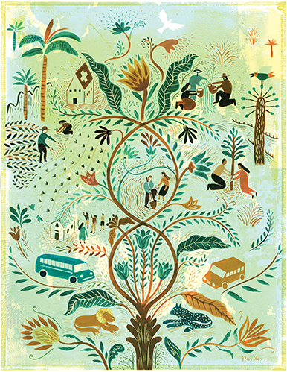
Reader 1: What kind of world do we want to leave to those who come after us, to children who are now growing up?…if these issues are courageously faced, we are led inexorably to ask other pointed questions: What is the purpose of our life in this world? Why are we here? What is the goal of our work and all our efforts? What need does the earth have of us? It is no longer enough, then, simply to state that we should be concerned for future generations. We need to see that what is at stake is our own dignity…[and] the ultimate meaning of our earthly sojourn.

Reader 2: An integral ecology is inseparable from the notion of the common good, a central and unifying principle of social ethics. The common good is “the sum of those conditions of social life which allow social groups and their individual members relatively thorough and ready access to their own fulfillment”…respect for the human person as such, endowed with basic and inalienable rights ordered to his or her integral development… common good calls for social peace, the stability and security provided by a certain order which cannot be achieved without particular concern for distributive justice.

For quiet personal reflection: 1 Minute of Silence
- What kind of world am I creating, and what am I leaving behind?

- How can I support an integral ecology in my work?
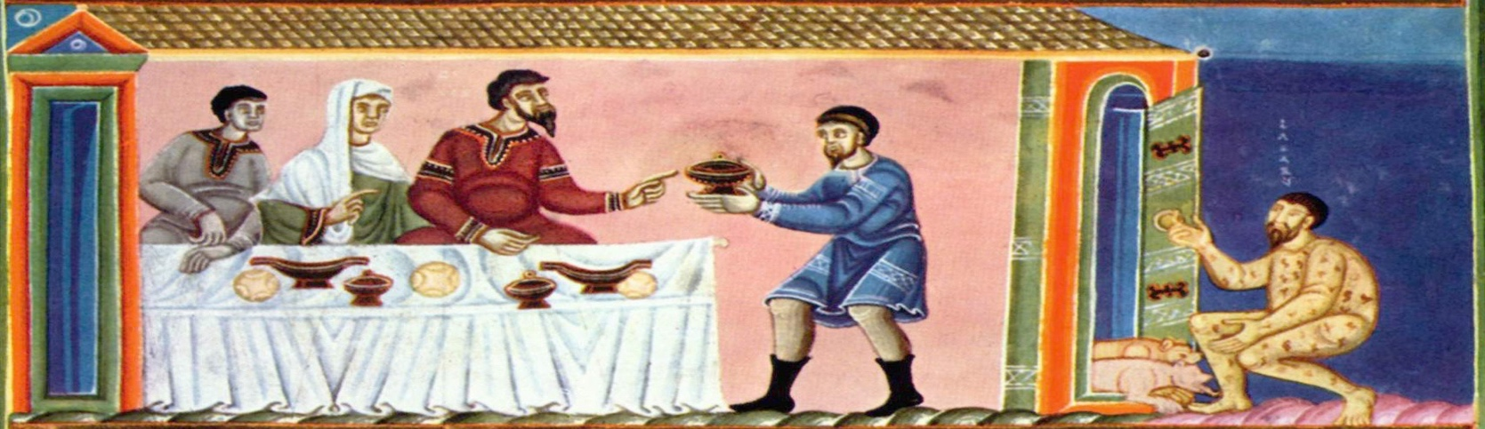

Reflection: Excerpts from Fratelli Tutti – Pope Francis (October 4, 2020)

Reader 1: Let us admit that, for all the progress we have made, we are still “illiterate” when it comes to accompanying, caring for and supporting the most frail and vulnerable members of our developed societies. We have become accustomed to looking the other way, passing by, ignoring situations until they affect us directly.
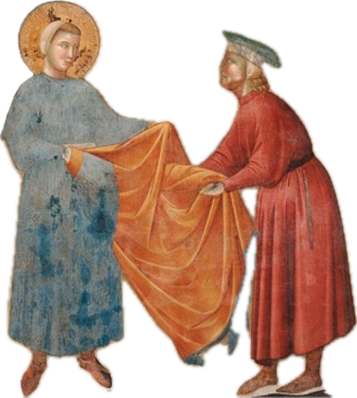

Reader 2: Education and upbringing, concern for others, a well-integrated view of life and spiritual growth: all these are essential for quality human relationships and for enabling society itself to react against injustices, aberrations and abuses of economic, technological, political and media power.

Reader 1: Only a gaze transformed by charity can enable the dignity of others to be recognized and, as a consequence, the poor to be acknowledged and valued in their dignity, respected in their identity and culture, and thus truly integrated into society.

For quiet personal reflection: 1 Minute of Silence
- How do I accompany the most frail; the most marginalized in my community?
- In my ministry, how do I teach: concern for others, a well-integrated view of life, and spiritual growth?

Intentions:
Leader: At this time, we bring forward our prayers and petitions. For what or for whom shall we pray?

(You are invited to share a petition, and at the conclusion say: We pray to the Lord.)

Response: Lord, hear our prayer.

Closing Prayer: From - A Christian prayer in union with creation (Laudati Si’ - Pope Francis May 24, 2015)

Triune Lord, wondrous community of infinite love, teach us to contemplate you in the beauty of the universe, for all things speak of you. Awaken our praise and thankfulness for every being that you have made. Give us the grace to feel profoundly joined to everything that is.

St. John Baptist de La Salle…, pray for us!
Live Jesus in our hearts…, forever!

