Integral Ecology

Let us remember…, that we are in the Holy Presence of God. (pause)

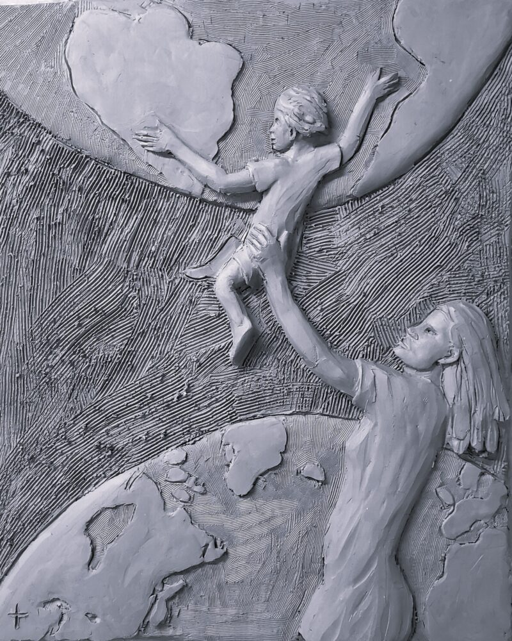
Each generation passes the world on to future humanity – Art by: Timothy Paul Schmalz

Opening Prayer:
Lord, you created us in your image and likeness. You created the heavens and the earth to sustain us and fill your world with life and beauty. Help us to see you in all things, and to recognize our shared responsibility to care for your creation as you care for us. Help us to see all things as connected, and good, and worthy. It is you who blesses all things, and brings life to all things. Help us not to take for granted, or destroy what you have created, and turn from your blessings. May we leave the world better than we inherited, and imitate Christ in love, generosity and grace for all creation. We ask this through Christ our Brother, now and forever, amen.

Bible Reading: Scripture Verses re: Care for Creation (USCCB, www.usccb.org retrieved October 13, 2025)

- Genesis 1:1-31
Reader 1: God made the heavens and the earth and it was good.
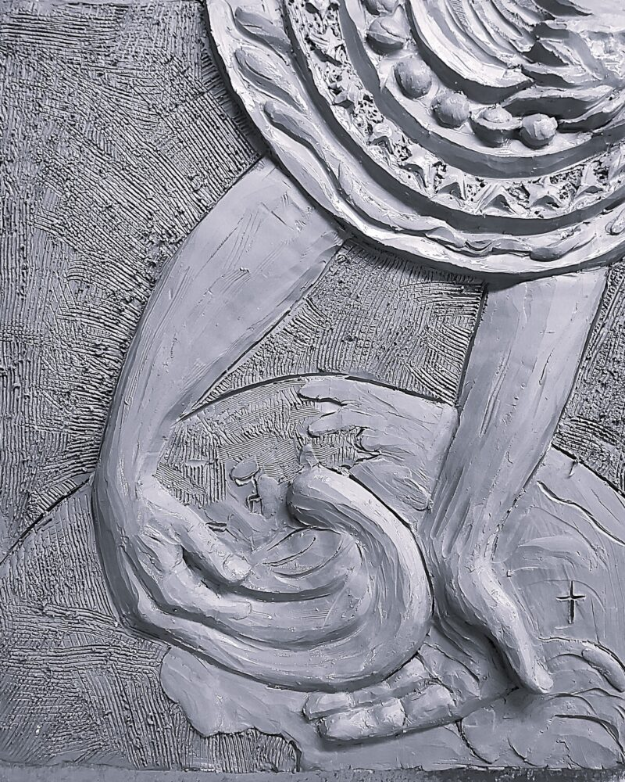
God the creator of all – Art by: Timothy Paul Schmalz

- Genesis 2:15
Reader 2: Humans are commanded to care for God’s creation.
- Leviticus 25:1-7
Reader 1: The land itself must be given a rest and not abused.
- Deuteronomy 10:14
Reader 2: All of heaven and earth belong to the Lord.
- Psalm 24:1-2
Reader 1: All the earth is the Lord’s.
- Daniel 3:56-82
Reader 2: Creation proclaims the glory of God.
- Matthew 6:25-34
Reader 1: God loves and cares for all of creation.
- Romans 1:20
Reader 2: Creation reveals the nature of God.
- 1 Corinthians 10:26
Reader 1: Creation and all created things are inherently good
because they are of the Lord.
- Excerpt from Laudato Si, #96
Reader 2: “Jesus took up the biblical faith in God the Creator, emphasizing a fundamental truth: God is Father (cf. Mt 11:25). In talking with his disciples, Jesus would invite them to recognize the paternal relationship God has with all his creatures. With moving tenderness he would remind them that each one of them is important in God’s eyes: “Are not five sparrows sold for two pennies? And not one of them is forgotten before God” (Lk 12:6). “Look at the birds of the air: they neither sow nor reap nor gather into barns, and yet your heavenly Father feeds them.”
.
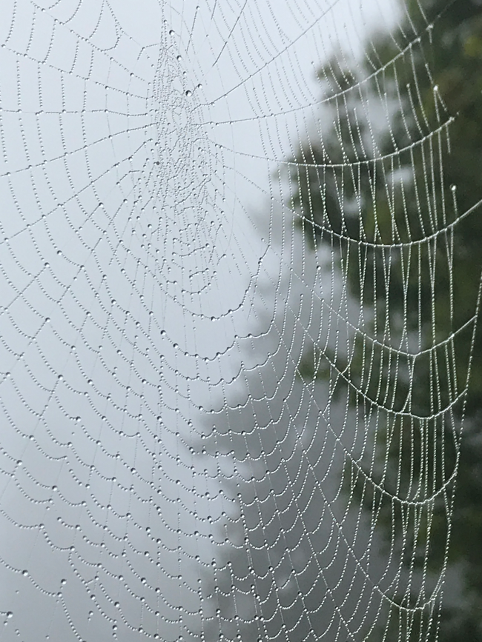
Reflection: Invocation - Poem by Everett Hoagland
From "Ghost Fishing: An Eco-Justice Poetry Anthology," (University of Georgia Press, 2018)
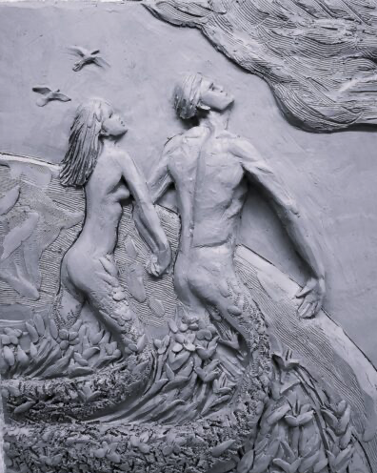
Humanity is created by earth’s dust – Art by: Timothy Paul Schmalz

Architect of icebergs, snowflakes,
crystals, rainbows, sand grains, dust motes, atoms.
Mason whose tools are glaciers, rain, rivers, ocean.
Chemist who made blood
of seawater, bone of minerals in stone, milk
of love. Whatever
You are, I know this,
Spinner, You are everywhere, in All The Ever-
Changing Above, whirling around us.
Yes, in the loose strands,
in the rough weave of the common
cloth threaded with our DNA on the hubbed, spoked
Spinning Wheel that is this world, solar system, galaxy,
universe.
Help us to see ourselves in all creation,
and all creation in ourselves, ourselves in one another.
Remind those of us who like connections
made with similes, metaphors, symbols
all of us are, everything is
already connected.
Remind us as the oceans go, so go we. As the air goes, so go we.
As other life forms on Earth go, so go we.
As our planet goes, so go we. Great Poet,
who inspired In The Beginning was The Word…,
edit our thoughts so our ethics are our politics,
and our actions the afterlives of our words.

For quiet personal reflection: (1 minute of silence)
- Where in my life recently have I seen myself in all of creation?

- What sort of legacy are my beliefs, ethics and actions leaving behind?

Reading: Conversion and Responsibility: L I V I N G T H E V I S I O N – (Lasallian Reflection 11, pg.11-12)
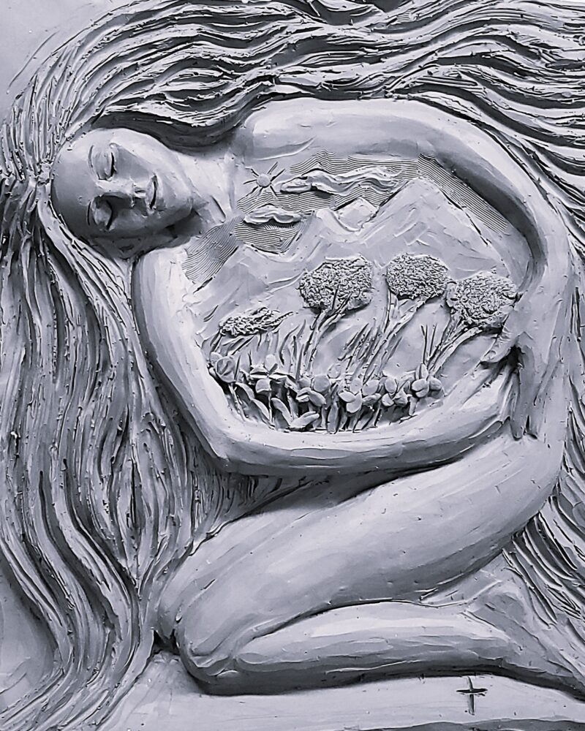
Nature is a central part of humanity – Art by: Timothy Paul Schmalz

This vision aligns with the Lasallian commitment to accompany each person in their search for meaning and for God. The Year of Lasallian Spirituality (2025) reminds us that essentially ours is an incarnational spirituality where the salvific nature of our mission is a gift extended to all. In this way, we carry out the call to accompany each person in their search for meaning and for God. And we must do so with the vision of Laudato si’ that calls us “to realize that a true ecological approach always becomes a social approach; it must integrate questions of justice in debates on the environment, so as to hear both the cry of the earth and the cry of the poor” (Laudato si’, 49).
Reflection: Excerpts from Laudati Si’ – (Pope Francis May 24, 2015)
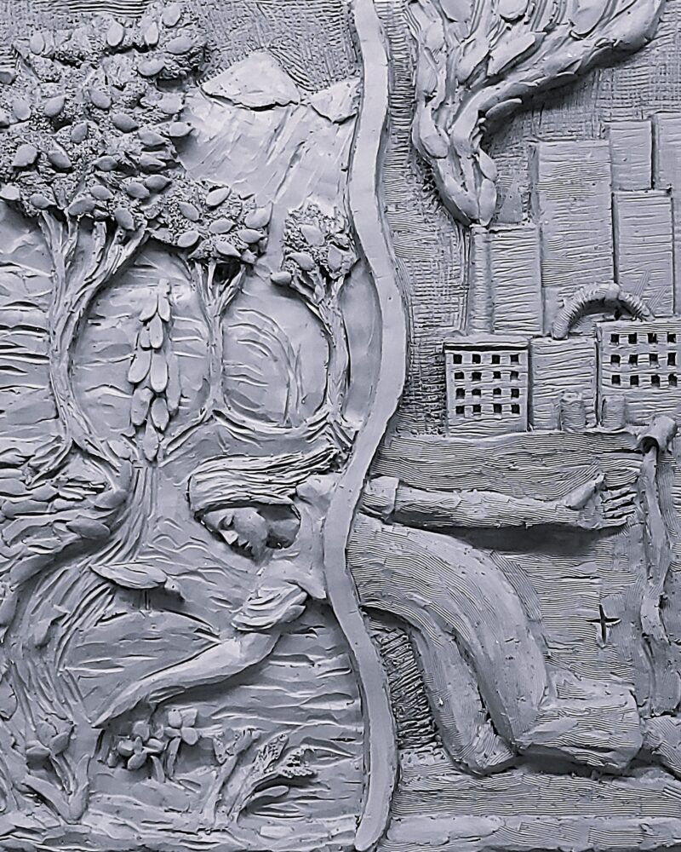
Beauty of nature should be accessible to all – Art by: Timothy Paul Schmalz
Reader 1: …..economic powers continue to justify the current global system where priority tends to be given to speculation and the pursuit of financial gain (56).

Reader 2: These situations have caused sister earth, along with all the abandoned of our world, to cry out, pleading that we take another course. Never have we so hurt and mistreated our common home as we have in the last two hundred years.....

Reader 1: The problem is that we still lack the culture needed to confront this crisis. We lack leadership capable of striking out on new paths and meeting the needs of the present with concern for all and without prejudice towards coming generations (53).

Reader 2: Nature cannot be regarded as something separate from ourselves or as a mere setting in which we live. We are part of nature, included in it and thus in constant interaction with it….(139)

Reflection: The Educational Mission: A LASALLIAN RESPONSE – (Lasallian Reflection 11, pg.9)

As Lasallians, our mission has always been to accompany the human person holistically. Education is our field of encounter, our laboratory of life. But how deeply have we embraced the call to educate for justice, peace, and the integrity of creation? Are we transforming our curricula to reflect the realities of climate change, displacement, and inequality?

For quiet personal reflection: (1 minute of silence)
- Where, in my local school curricula, do we reflect the realities of climate change?

- How deeply has my school embraced the call to educate for justice, peace and the integrity of creation?

Intentions:
Leader: At this time, we bring forward our prayers and petitions. For what or for whom shall we pray?
(You are invited to share a petition, and at the conclusion say: We pray to the Lord.)
Response: Lord, hear our prayer.
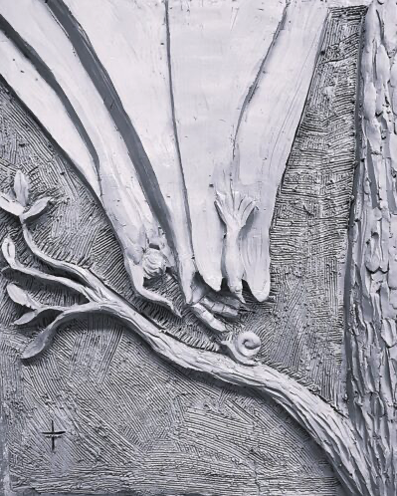
The Trinity is in all creatures – Art by: Timothy Paul Schmalz

Closing Prayer: Excerpt from: A Christian prayer in union with creation – (Laudato Si’)

God of love, show us our place in this world as channels of your love for all the creatures of this earth, for not one of them is forgotten in your sight. Enlighten those who possess power and money that they may avoid the sin of indifference, that they may love the common good, advance the weak, and care for this world in which we live. The poor and the earth are crying out. O Lord, seize us with your power and light, help us to protect all life, to prepare for a better future, for the coming of your Kingdom of justice, peace, love and beauty. Praise be to you! Amen.

St. John Baptist de La Salle…, pray for us!
Live Jesus in our hearts…, forever!

