All is Connected

Let us remember…, that we are in the Holy Presence of God. (pause)

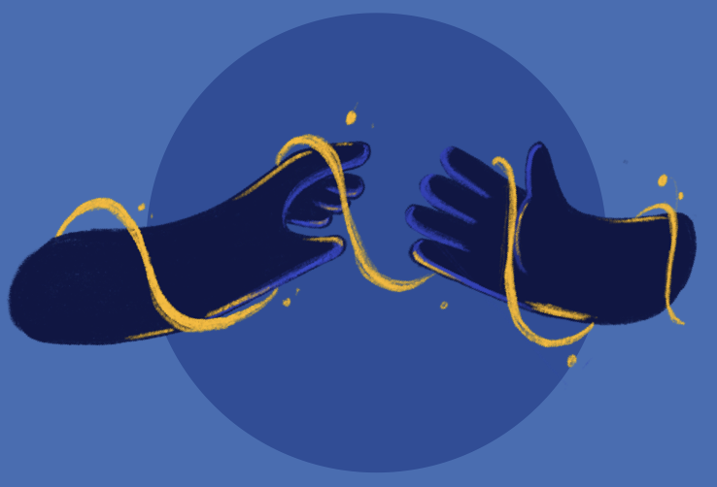
Opening Prayer:
Lord, you call us and guide us. You invite us to build bridges where there are divides, pursue dialogue when voices are silent, and soften hearts when they are hardened. May we see your light before us, and move closer to you. May we always pursue a path that brings us closer together; closer to peace. May we always be mindful of our connectedness as Brothers and Sisters in Christ, your Son and our savior. We pray this in Jesus’ name. Amen.

Bible Reading: John 10 (11-16)
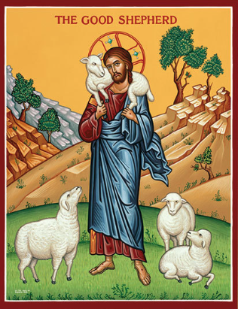
I am the good shepherd. A good shepherd lays down his life for the sheep. A hired man, who is not a shepherd and whose sheep are not his own, sees a wolf coming and leaves the sheep and runs away, and the wolf catches and scatters them. This is because he works for pay and has no concern for the sheep. I am the good shepherd, and I know mine and mine know me, just as the Father knows me and I know the Father; and I will lay down my life for the sheep. I have other sheep that do not belong to this fold. These also I must lead, and they will hear my voice, and there will be one flock, one shepherd.

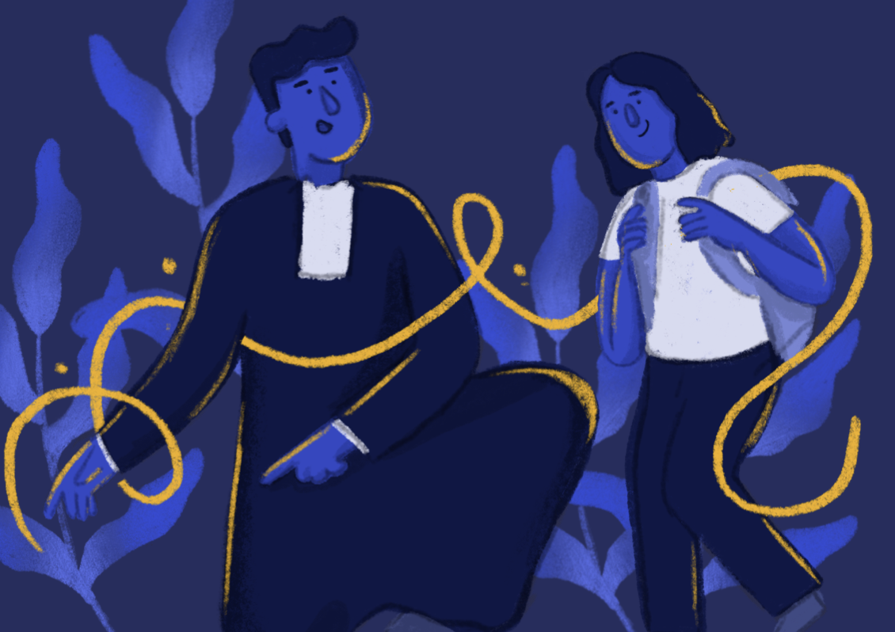

Reflection: The Community of Creation and Universal Fraternity - (Lasallian Reflection 11: 2025-2026 pg.4)

“In the beginning…”. These familiar words ground us in the Genesis narrative of creation. Throughout centuries and millennia, we hearken back to these narratives as a reminder of that perfect union between creation and the Creator. While we can discuss theological truths that take this perfect union as its root, we are being asked today to urgently embrace that, from the beginning, all is connected. That each of us has a responsibility for rebuilding and fostering the community of creation. Amid environmental and societal crises, we are called to (re)discover the deep significance that from the beginning all is connected.

For quiet personal reflection: (1 minute of silence)
- Where in my life currently do I feel most “connected”?
- Where in my life currently do I feel most “disconnected”?

Reflection: Everything is Connected - (Andrea Sarubbi, www.popesprayerusa.net, retrieved Oct. 13, 2025)

Reader 1: Eight hundred years ago, in 1225, St. Francis of Assisi wrote the Canticle of the Creatures: a prayer of praise that many Italian students still learn by heart in school today. Ten years ago, in 2015, Pope Francis published the encyclical Laudato Si’: one of the most widely read and quoted papal encyclicals ever. The two anniversaries celebrated this year give special meaning to the Season of Creation 2025, the period from September 1 to October 4—the feast of St. Francis—which unites Christians of different denominations in prayer and action for the care of the Earth.


Reader 2: In his prayer intention for October 2025, Pope Leo XIV asks us to pray “for our relationship with all creation.” He does so with a Franciscan slant: “Let us pray that, inspired by St. Francis, we may experience our interdependence with all creatures, loved by God and worthy of love and respect.”

Reader 1: The key word is, of course, interdependence, and the concept of integral ecology—or integral human development, as the name of the Vatican department that supports this month’s prayer intention suggests—it reminds us precisely of this: that if we care for the Earth, we also care for humanity, and vice versa. Because “everything is connected,” as Francis wrote ten years ago in Laudato Si’. Humanity and the environment are connected; prayer and action are connected.

Reader 2: [When we truly open our eyes and look around, we can see] …the beauty of creation, of the value of every living being … and the task entrusted to us: to recognize the presence of God in creation and to feel “responsible for this common home,” taking care of every life “in all its forms and possibilities.”

Reader 1: Prayer thus becomes action, a concrete gesture. This is demonstrated every day by all the fruits born from the seed of St. Francis of Assisi, or by the many experiences around the world that are keeping alive and putting into practice the teachings of Laudato Si’.

For quiet personal reflection: (1 minute of silence)
- Where, in my life recently, have I seen the presence of God?
- Did recognizing God’s presence make me feel more connected to all things?



Reflection: Excerpt from Laudato Si - #240, (Pope Francis, 6/18/2015)


“The human person grows more, matures more and is sanctified more to the extent that he or she enters into relationships, going out from themselves to live in communion with God, with others and with all creatures. In this way, they make their own that trinitarian dynamism which God imprinted in them when they were created.”

Intentions:

Leader: At this time, we bring forward our prayers and petitions. For what or for whom shall we pray?

(You are invited to share a petition, and at the conclusion say: We pray to the Lord.)

Response: Lord, hear our prayer.

Closing Prayer: Let us celebrate the blessing of God in all creation as we pray together:
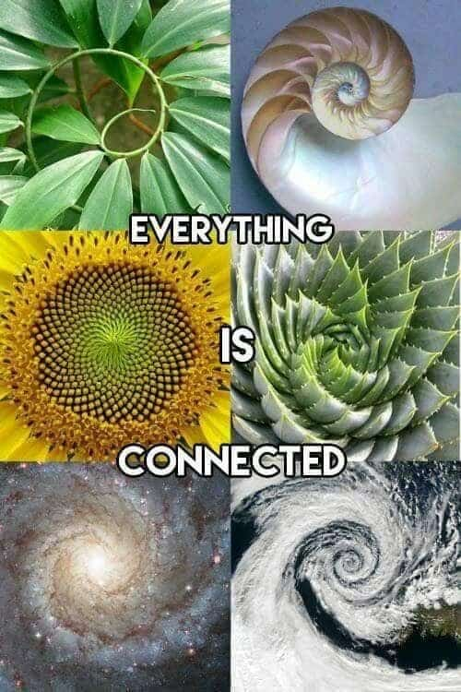

(All) God of the glistening sun on the ocean,
The wind whispering in the trees,
The laughter of the children,
The wisdom of the elders.
Help us to recognize
The oneness of all things
And celebrate human creativity,
Compassion, endurance and love.
Empower us to recognize
The oneness of all things
In the wonder of Your creation. Amen.

St. John Baptist de La Salle…, pray for us!
Live Jesus in our hearts…, forever!

